Efficient Assessment of Credible Regulation Potential from Uncertainty Affected Gas Networks

Peiyao Zhao, *Student Member, IEEE*; Zhengshuo Li, *Senior Member, IEEE*

## A. Detailed Parameters of the Systems in Case Studies

## 1) E22-N10 system

**Fig. 1.** E22-N10 system

Parameters of the pipeline network

|  |  |  |  |  |  |
| --- | --- | --- | --- | --- | --- |
| Pipe | Form node | To node | Friction coefficient | Lengths (m) | Diameter (m) |
| 1 | 1 | 2 | 0.01 | 10000 | 1 |
| 2 | 2 | 3 | 0.01 | 25000 | 0.7 |
| 3 | 2 | 4 | 0.01 | 10000 | 0.7 |
| 4 | 4 | 5 | 0.02 | 20000 | 0.7 |
| 5 | 5 | 6 | 0.02 | 20000 | 0.7 |
| 6 | 6 | 7 | 0.02 | 20000 | 0.7 |
| 7 | 4 | 8 | 0.01 | 15000 | 0.7 |
| 8 | 8 | 9 | 0.02 | 25000 | 0.7 |
| 9 | 8 | 10 | 0.02 | 25000 | 0.7 |

Parameters of the units

|  |  |  |  |
| --- | --- | --- | --- |
| Unit1 | Bus | Max output (MW) | Generation price ($/MWh) |
| C1 | 10 | 200 | 4800 |
| C2 | 17 | 200 | 5400 |
| C3 | 19 | 200 | 6000 |
| C4 | 4 | 200 | 6600 |
| G1 | 16 | 1000 | 3000 |
| G2 | 13 | 1000 | 2760 |
| G3 | 18 | 1000 | 2520 |
| G4 | 15 | 1000 | 2160 |

1:C1-C4 denote the thermal power units, and G1-G4 denote the GFUs.

Gas loads in N10 system

|  |  |  |
| --- | --- | --- |
| Gas load | Node | Demand (kg/s) |
| 1 | 3 | 10 |
| 2 | 4 | 11 |
| 3 | 5 | 10 |
| 4 | 6 | 10 |
| 5 | 7 | 9 |
| 6 | 9 | 10 |
| 7 | 10 | 10 |

## 2) E39-N20 system



**Fig. 2.** E39-N20 system

Parameters of the pipeline network

|  |  |  |  |  |  |
| --- | --- | --- | --- | --- | --- |
| Pipe | Form node | To node | Friction coefficient | Lengths (m) | Diameter (m) |
| 1 | 1 | 2 | 0.01 | 10126 | 1 |
| 2 | 2 | 3 | 0.01 | 10061 | 1 |
| 3 | 3 | 4 | 0.01 | 9928 | 1 |
| 4 | 4 | 5 | 0.05 | 10102 | 0.7 |
| 5 | 5 | 6 | 0.05 | 10120 | 0.7 |
| 6 | 6 | 7 | 0.05 | 10066 | 0.7 |
| 7 | 4 | 8 | 0.02 | 10083 | 0.8 |
| 8 | 8 | 9 | 0.02 | 10080 | 0.8 |
| 9 | 9 | 10 | 0.02 | 10004 | 0.8 |
| 10 | 10 | 11 | 0.02 | 10061 | 0.8 |
| 11 | 11 | 12 | 0.02 | 9957 | 0.7 |
| 12 | 12 | 13 | 0.02 | 10072 | 0.7 |
| 13 | 13 | 14 | 0.02 | 9927 | 0.7 |
| 14 | 14 | 15 | 0.02 | 9980 | 0.7 |
| 15 | 11 | 16 | 0.02 | 9930 | 0.7 |
| 16 | 16 | 17 | 0.02 | 9941 | 0.7 |
| 17 | 17 | 18 | 0.02 | 10097 | 0.7 |
| 18 | 8 | 19 | 0.02 | 10069 | 0.7 |
| 19 | 19 | 20 | 0.02 | 9988 | 0.7 |

Parameters of the units

|  |  |  |  |
| --- | --- | --- | --- |
| Unit1 | Bus | Max output (MW) | Generation price ($/MWh) |
| C1 | 30 | 200 | 4800 |
| C2 | 37 | 200 | 5040 |
| C3 | 38 | 200 | 5280 |
| C4 | 39 | 200 | 5520 |
| C5 | 36 | 200 | 2160 |
| G1 | 31 | 1000 | 2400 |
| G2 | 32 | 1000 | 2880 |
| G3 | 33 | 1000 | 3360 |
| G4 | 34 | 1000 | 3840 |
| G5 | 35 | 1000 | 4320 |

1:C1-C5 denote the thermal power units, and G1-G5 denote the GFUs.

Gas loads in the N20 system

|  |  |  |
| --- | --- | --- |
| Gas load | Node | Demand (kg/s) |
| 1 | 4 | 40 |
| 2 | 7 | 30 |
| 3 | 8 | 10 |
| 4 | 11 | 30 |
| 5 | 15 | 40 |
| 6 | 18 | 30 |
| 7 | 20 | 20 |

This study focuses on the impact of gas withdrawal fluctuations of gas turbines on the gas network, and other gas loads are assumed to remain unchanged within a 1-hour real-time dispatch period.

## B. Results in Case Studies

## 1) Time-varying Gas Load Profiles

The time-varying gas load profiles of gas turbines in Section V.C are shown in Fig.3.

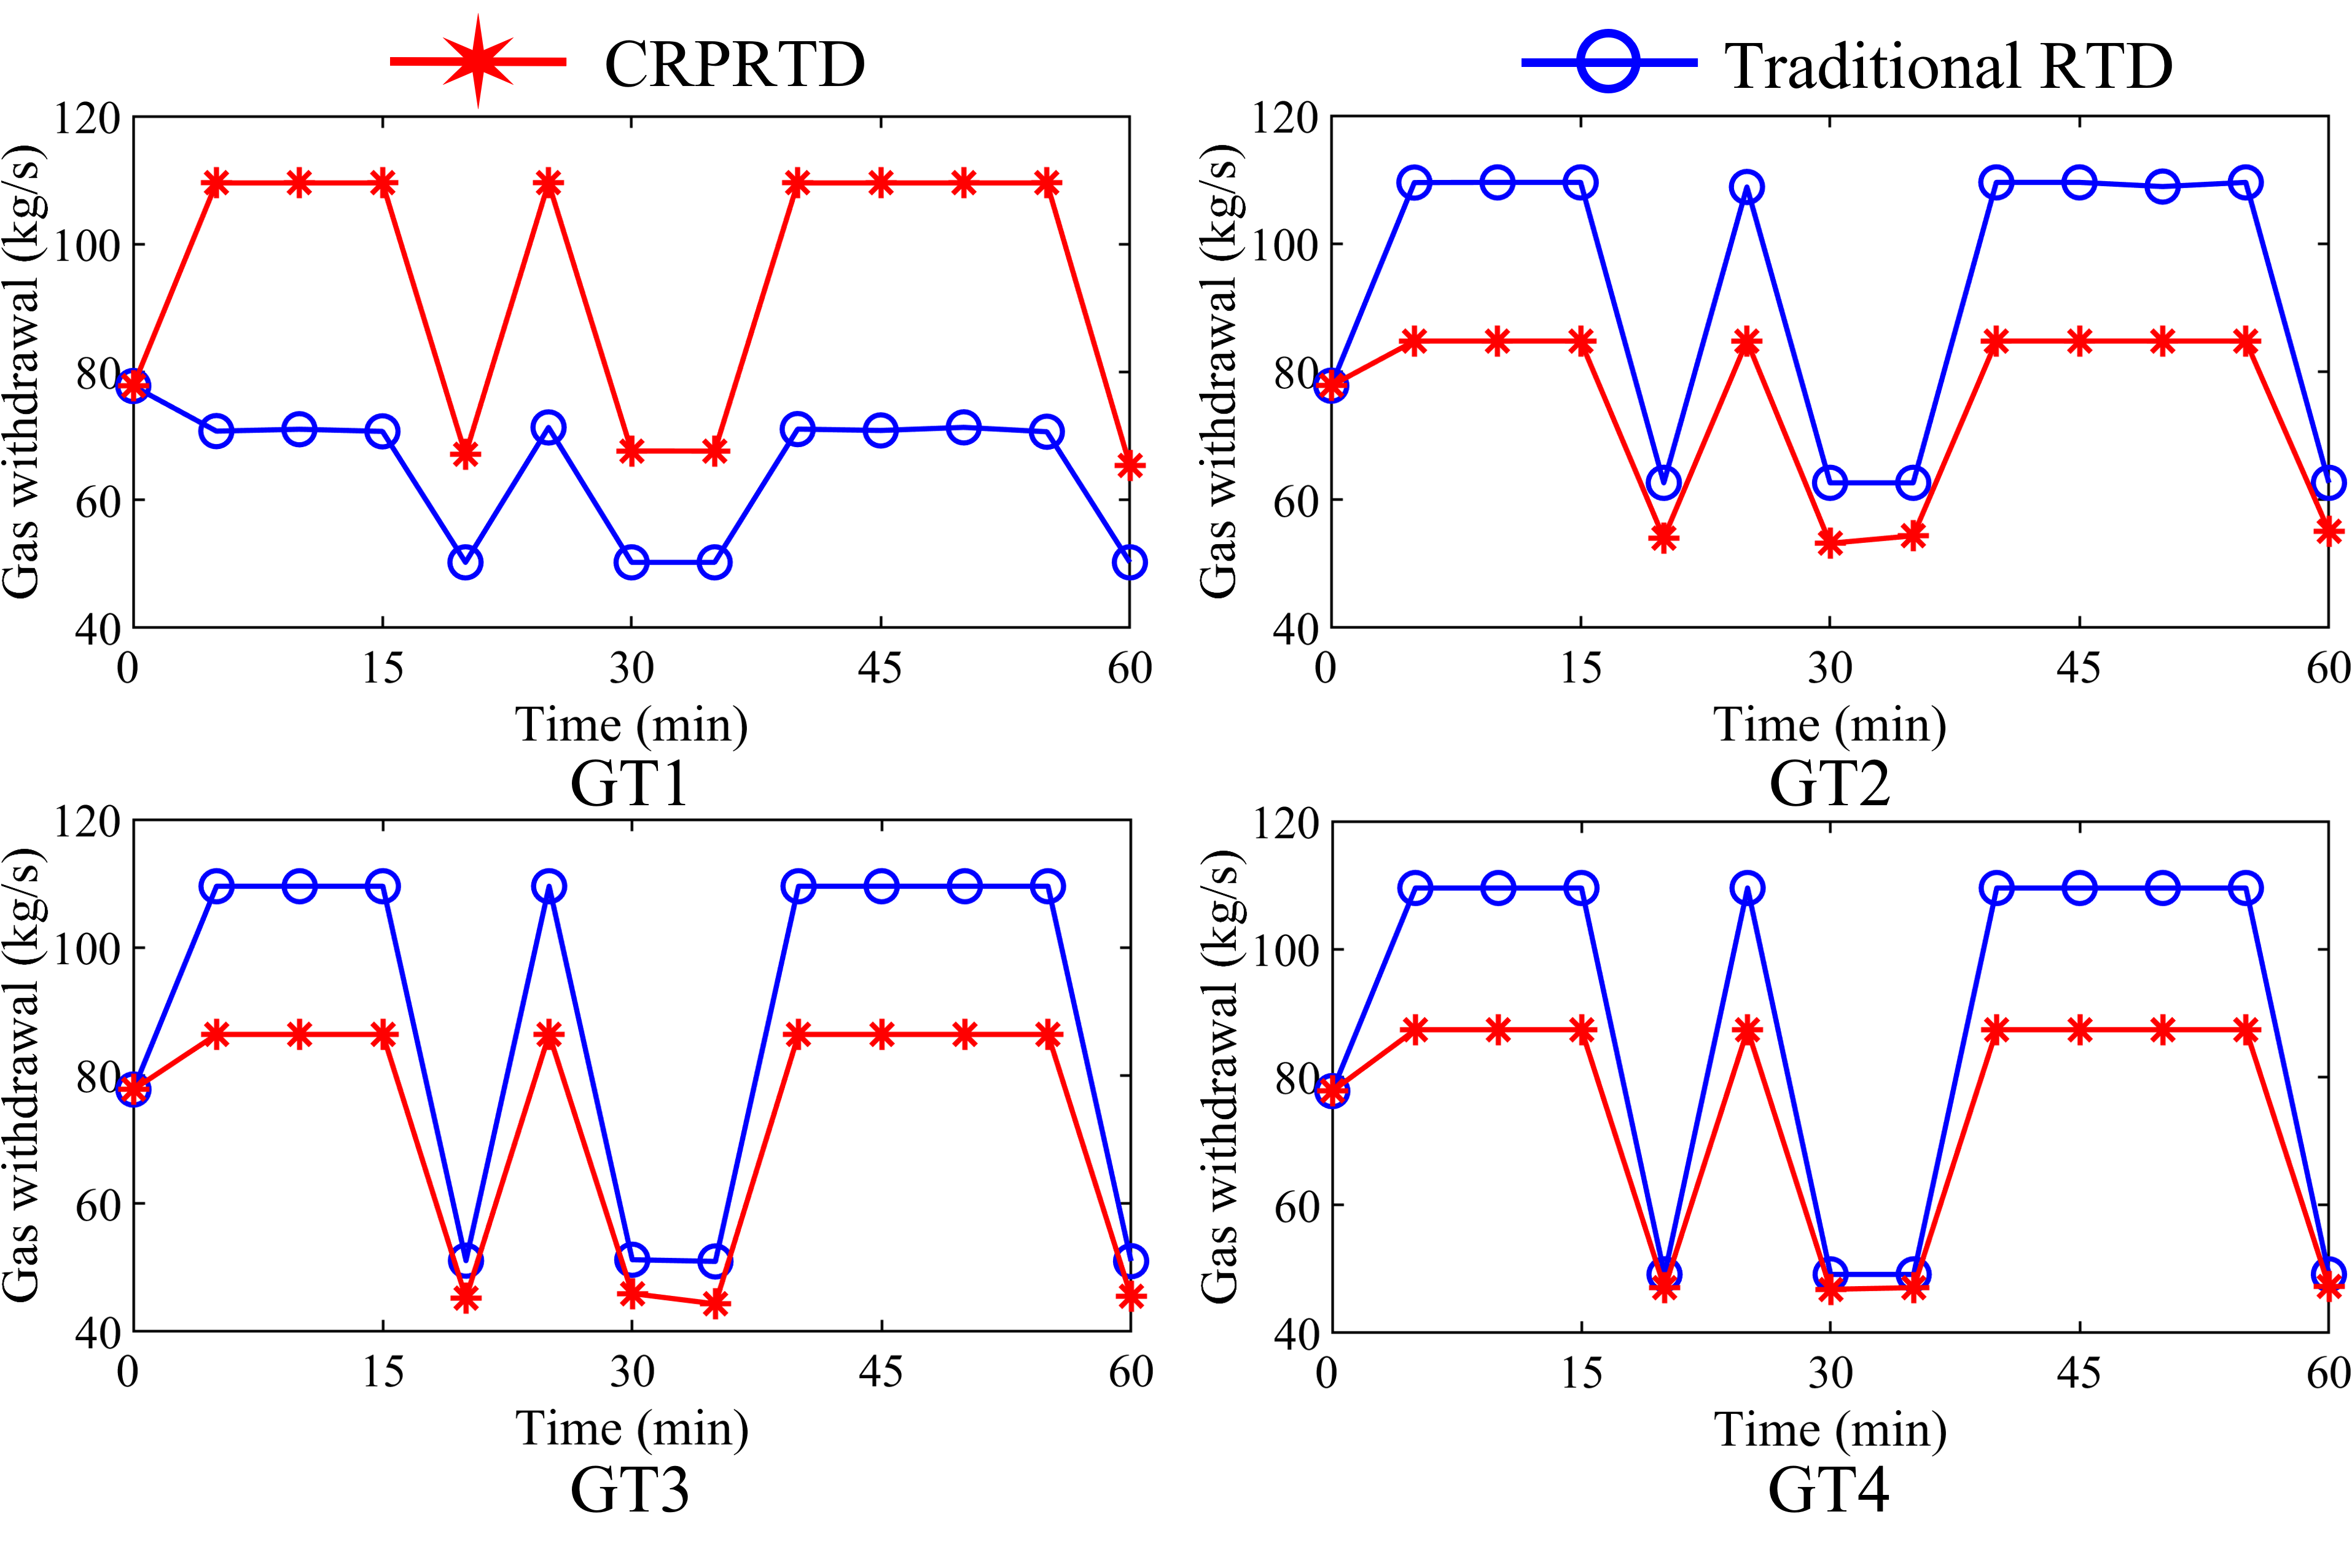

**Fig. 3.**  The gas withdrawals of GTs in the E22-N10 system.

## 2) Time-varying Linepack Profiles

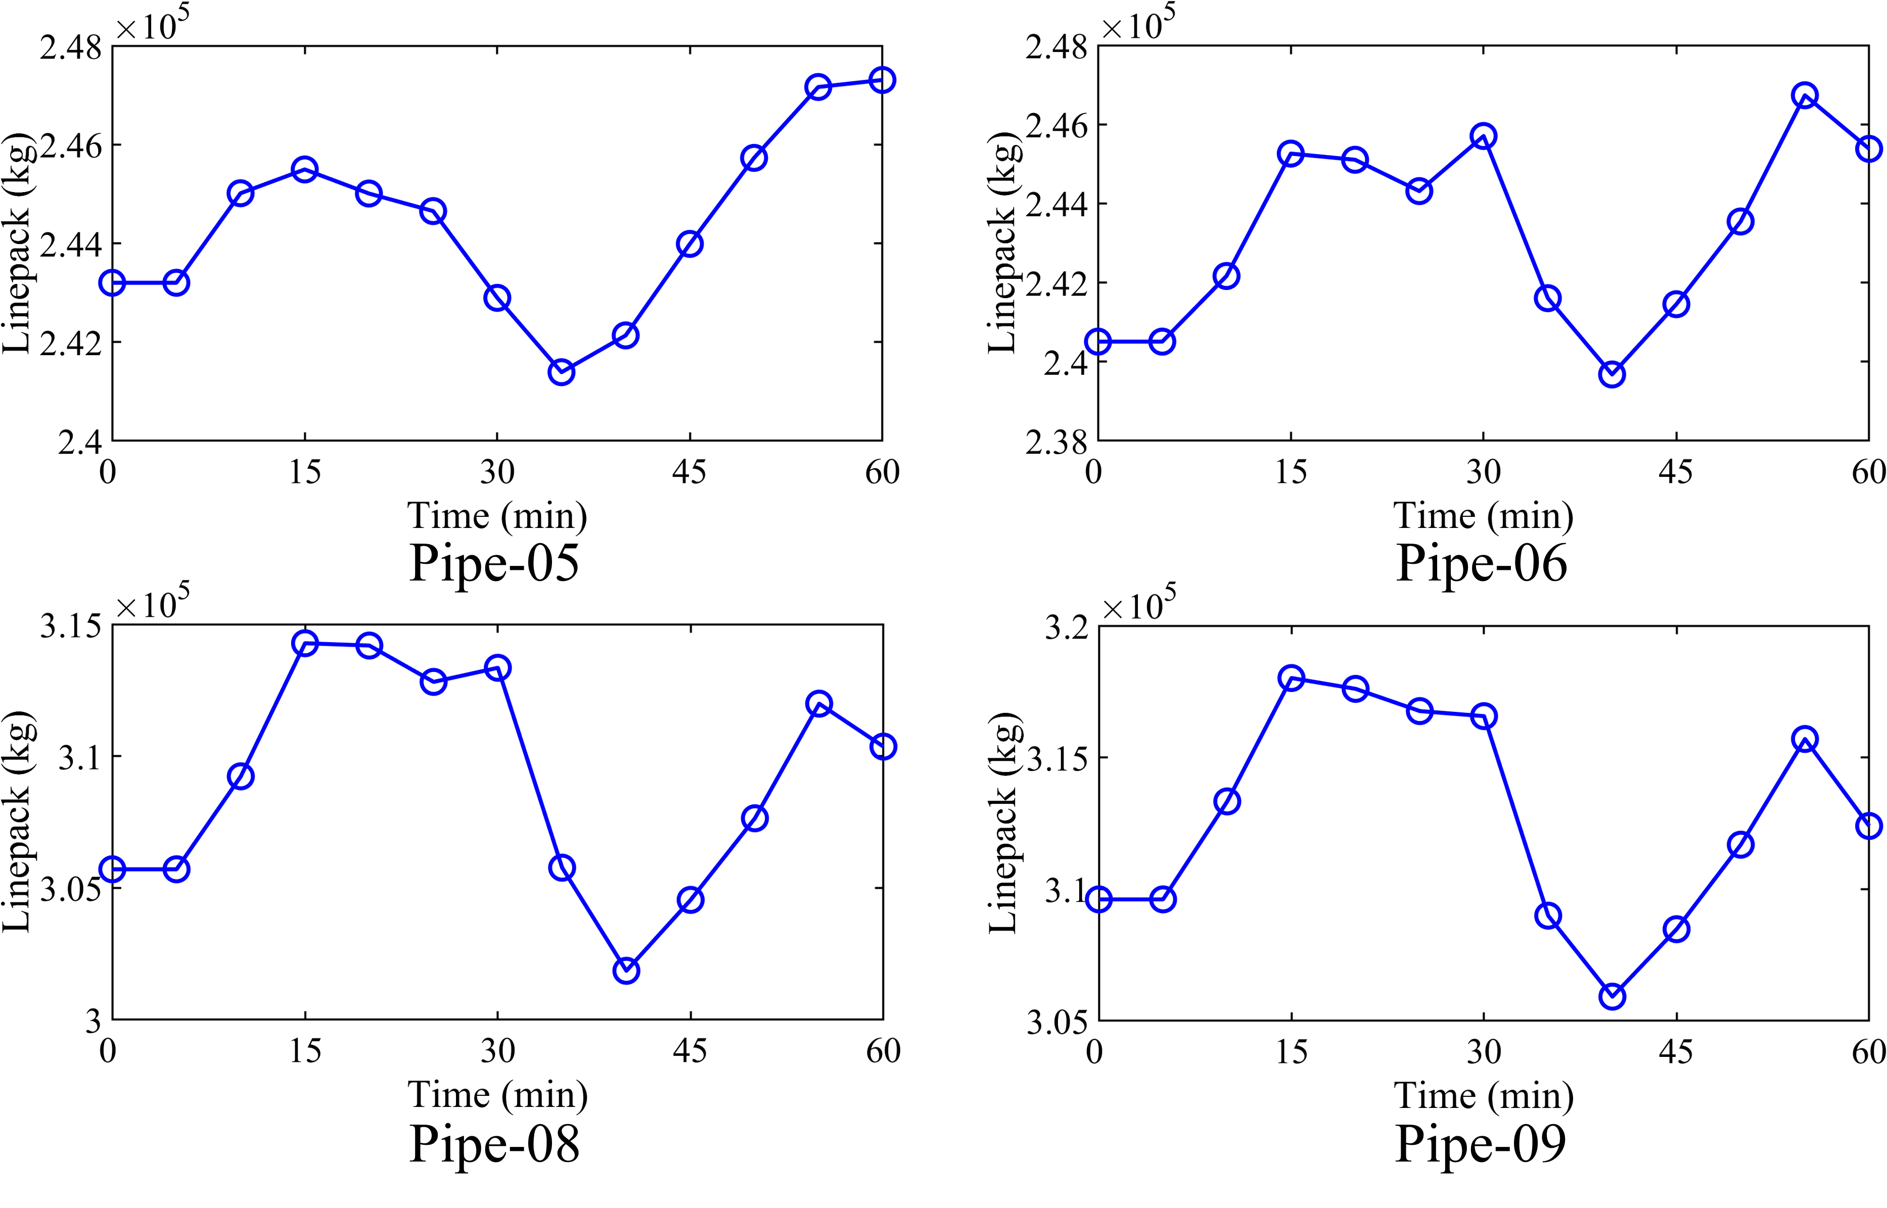

**Fig. 4.**  The linepack of pipelines in the E22-N10 system.

## 3) CRP Model with Different Spatial Resolution

Finer spatial resolution for the pipeline discretization will lead to a greater computational burden. In our case studies, we set the number of discrete segments to *Nd*=2 and *Nd*=3, respectively, and compare the computational performance of the CRP assessment model on the N10 system. The results are shown in Table II. According to the results shown in Table II, the CRP assessment results with different spatial resolutions are similar, with an average relative error of about 0.83%. However, the solution time of the CRP assessment model with *Nd*=2 is significantly shorter than the model with *Nd*=3. Therefore, the spatial resolution for the pipeline discretization in our case studies is set to *Nd*=2. Moreover, it is worth mentioning that the selection of the above discretization spatial resolution may be applicable to the case studies of this manuscript, but for different systems in other studies, specific tests are still needed.

TABLE II

Solution time and CRP obtained by the model with different spatial resolutions

|  |  |  |  |  |  |
| --- | --- | --- | --- | --- | --- |
| Spatial resolution | Solution time (s) | Gas turbine | Lower bound of CRP (kg/s) | | Upper bound of CRP (kg/s) |
| *Nd*=2 | 10.19 | GT1 | | 1 | 109 |
| GT2 | | 0 | 94 |
| GT3 | | 0 | 92 |
| GT4 | | 0 | 89 |
| *Nd*=3 | 37.93 | GT1 | | 1 | 109 |
| GT2 | | 0 | 94 |
| GT3 | | 0 | 93 |
| GT4 | | 0 | 91 |